* **Conditional probability(formula)**

described as:

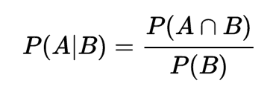

* **Total probability (formula)**

The law of total probability states a partition of any sample space is nothing but a collection of events that are disjoint. The total probability can be used to find the probability of an event A when you don’t know enough about A’s probability, instead you take a related Event B and calculate probability of A in terms of B.

*P(A) = P(A∩B) + P(A∩Bc).*

* **Chain Rule (formula)**

The Chain rule permits the calculation of any member of the disjoint distribution of a set of random variables using only conditional probabilities.



* **Prior**

It is the probability that expresses an uncertain quantity with no evidence teken into account, or well the probability given to a root note.

* **Posterior**

It is the probability of an event that is assigned after the relevant evidence is taken into account.

* **Conditional Dependence**

It is the relationship between two or more events given that a third event occurs. If A and B are responsible for C, the posterior occurrence of A will reduce the probability of B.

* **Conditional Independence**

X and Y are conditionally independent given Z if and only if, given any value of Z, the probability distribution of X is the same for all values of Y and the probability distribution of Y is the same for all values of X.

* **Distribution of Probability / Probability distribution**

The probability distribution is the mathematical function that provides the value on of the probability of occurrence of different outcomes.

* **Bayes Theorem**

It allows us to update the probabilities of variables whose state not been observed given some set of new observations.

* **Bayesian Network**

A graphical structure that allows us to represent and reason about an uncertain domain. It is represented by nodes as variables and a set of arks that lnk and connects each pair of nodes.